DATA PROCESSING PROCEDURES 06:

TABLES EDITOR

**Table of Contents**

1. Overview 3

1.1 Interface with CSPro 3

1.2 Modifications to Tables 3

1.3 The Parameters File 3

1.4 Table Commands 5

2. Using Tables Editor Interactively 6

2.1 Open a File 6

2.2 Change Global Parameters 6

2.3 Select a Table 7

2.4 Suppress Printing 8

2.5 Enable Footnote 8

2.6 Change Sizes 9

2.7 Change the Number of Decimals & Suppress Rows, Columns, or Layers 10

2.8 Save Selected Table to a RTF File/Copy to Clipboard 11

2.9 Save All Tables to a RTF File 12

2.10 Save Modifications 12

# 1. Overview

The purpose of the Tables Editor is to facilitate the importing of CSPro tables into Rich Text File (RTF) format used by Microsoft products such as Word and Office. RTF format is readable by most word processors. This tables editor utility can create an RTF document with all your tables just by double-clicking on the .TBD file. In addition, by using this utility interactively, specifically selected tables can be copied into the clipboard or all the tables can be saved into an RTF file.

## 1.1 Interface with CSPro

When a CSPro batch program that generates tables runs, it creates a TBD file with the same name of the application that was used to create the tables. This is a binary file that contains all the information required to print a table. Information such as the values in the cells, the title, the variables in each dimension, the variable and value labels, the number of decimals to be printed, and whether the table should be printed, among others, is contained in the TBD file.

TablesEditor uses this TBD file as input to produce tables that resemble the way that they are presented in the DHS final reports. This utility is set to take care of most of the DHS format procedures. There are few other alterations that can be done interactively or by manually writing on the parameters file.

The following modifications are done automatically:

* Line dividers and periods that follow the labels in the rows and other pieces of data that are not exported into the tables printed in reports, are removed.
* The titles are adjusted according to the table width.
* If stubs are present, they are adjusted and positioned to the left-hand side of the table where they are normally presented in the reports.
* Layers are printed in upper case letters in the middle of the table.
* Rows or columns with no values are discarded.
* Variable labels are bold, and categories are indented under the variable label

## 1.2 Modifications to Tables

There are two ways to specify modifications for a table: The first way is to use a parameter file and the second way is to make them interactively. If there is no parameter file, any modification done interactively will generate a .PRM file where your modification will be saved. To do the latter the table needs to be selected and the changes will be specified using a context menu.

## **1.3 The Parameters File**

The parameters file is used to provide **“TablesEditor”** with instructions to modify the presentation of a table. The parameters file must have the same name as that of the application used to generate the tables with the extension PRM. The parameters file must reside in the same directory as the TBD file. If no parameters file is provided, when opening a .TBD file, **TablesEditor** will display a warning message saying that the .PRM file was not found and any parameter set in the CSPro application will be used as default. (i.e., if a table was declared in CSPro as float (2), **TablesEditor** will print it with 2 decimals).

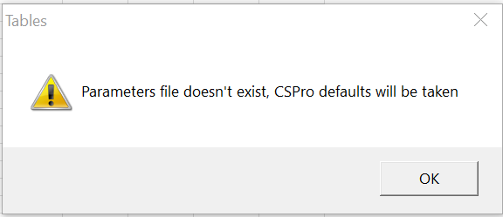

Commands in the parameters file can be written using any text editor. They are not case sensitive, meaning that they can be written either in upper- or lower-case letters. The format for the commands is free using blanks or commas as separators; they can take as many lines as desired. In the parameters file the user can also define footnotes for the table.

Comments can be used in the same way that they are used in CSPro by opening and closing them with braces{}. Nested comments are allowed as well. Except for comments, all commands should be finished with a semicolon. **TablesEditor** will display messages in a window to report problems found when compilating the instructions provided by the user in the parameters file.

There are 2 types of commands: Global Commands and Table Commands. Global commands apply to all the tables in the application while table commands apply specifically to the table that they refer to. All global commands should appear at the beginning of the parameters file.

|  |  |  |  |
| --- | --- | --- | --- |
| **Global Commands:** | | | |
| **Command** | **Type** | **Default value** | **Description** |
| **decimals** | [comma/  period]; | Period | This parameter specifies the character to be used to separate decimals. The default is period, but it can be changed to commas |
| **thousands** | [comma/period/blank/none]; | Comma | This parameter specifies the character to be used to separate thousands. The default is commas, but it can be changed to periods, blanks, or not to use any separator at all. |
| **Style** | [dhs1 / dhs2] | dhs1 | Between the first and the second version of TablesEditor, there was some adjustment to the presentation of the DHS final report tables. The majority of the adjustment was made to the border, titles, and column/row labels. “**dhs1**” is the new style and “**dhs2”** is the old format. |

If the parameter file is created by the TablesEditor, by default the following global command will be added at the beginning of the .PRN file.

|  |
| --- |
| decimals period;  thousands comma;  style dhs1; |

Thousands and decimals are particularly useful for tables for French-speaking countries where the convention is to use commas to separate decimals and periods to separate thousands. If all the global defaults are taken, then no global commands are required to be present in the parameters file. [ALBERT TO CHECK ]

## 1.4 Table Commands

A table command can be repeated as many times as the total number of tables declared in the application. The purpose of this command is to change the number of decimals in the columns or rows; to suppress the printing of columns, rows, or layers, to define footnotes for the table or to disable the printing of a table at all. This command takes only effect on the table where it is specified.

|  |
| --- |
| **Commands** |
| TableName [noprint]; TableName [stubsize = number of twips ] [cellsize = number of twips ];TableName [footnote]; TableName [footnote <Footnote text> endfootnote ]; TableName [columns/rows/layers] [VarName(occurrence) = categories/action]; |
| **Description** |

|  |
| --- |
| TableName[**noprint**]; |
| **TableName** Is the name of a table as declared in the CROSSTAB command in the CSPro application.  **[noprint]** is used to exclude the table from printing. If this parameter is used after a table name, the TablesEditor will not print the table regardless of whether the noprint command was used or not in the CSPro application. If noprint is used, this should be the only parameter for that table. |

|  |
| --- |
| TableName [**stubsize** = number of twips ] [**cellsize** = number of twips ]; |
| **Stubsize** parameter specifies the cell size in twips to be used for the table stub column. The stub is the first column in the table where the variable and value labels are displayed.  **Cellsize** parameter specifies the cell size in twips to be used for other columns but the stub. All cells in a table except for the stub have the same size. The stubsize and cellsize parameters should not be mixed with other commands, and they should stand by themselves after a table name. Both of these commands are optional. For either command that is not present TablesEditor will calculate its sizes. |

|  |
| --- |
| TableName [**footnote** <**Footnote text**> **endfootnote** ]**;** |
| In this footnote parameter the actual text for the footnote should be typed in between the words **footnote < > endfootnote.** Make sure that only one semicolon is present, and it should be after the word **endfootnote**. There is no limit as to how many footnotes can be included. If a footnote number is needed the **'@'** character should be immediately typed before the number. This will ensure that the number will get translated as superscript. For TablesEditor to know when a footnote is completed the tilde **'~'** should be typed at the end of each footnote. This generates a hard return in the space provided for the footnotes. Remember that once all footnotes are typed the following line should end up with the word **endfootnote** followed by a **semicolon ';'**. The footnote cannot be combined with other parameters in the same table declaration. |

|  |
| --- |
| TableName [**columns/rows/layers**] [ [**VarName**(occurrence) = **categories/action** ]; |
| As variables can be part of any dimension in a table, it is necessary to specify to which dimension the variable to be modified belongs to (**columns/rows/layers)**. Once the dimension is established, all variables that require modifications for that dimension can be declared. All three dimensions can be modified in a simple command without having to name the table again.**VarName** is referencing to the variable name as used in the crosstab table declaration of the CSPro application, where the modification will take place.  There are some variables that may appear more than once in the same dimension. The **occurrence** specifies which of those variables has to be modified. It is important to note that this parameter refer to the occurrence of the variable and not to its position in the declaration (as it is the case with the TBLCOL, TBLROW and TBLLAY post-processing CSPro commands).  If no occurrence is specified, TablesEditor will modify the first variable with the same VarName found in the dimension. The occurrence number has to be specified between parentheses.The parameter **category** is a number that specifies which category of the variable is going to be modified. A special case is when all categories of the variable are going to be modified. In this case instead of a category code the word ALL can be used.  The **action** parameter specifies what action will take place in the category of the variable (VarName) described previously. The possible values for this parameter are:   * **A NUMBER,** indicates the number of decimal positions to be printed. * **NODEC**, the no decimals parameter is exactly the same as saying that the number of decimals is zero (0). The parameter is provided for clarification purposes. * **SUPPRESS,** with this parameter the column, row, or layer of the category in the variable (VarName) previously declared is eliminated from the table. Since tables are presented in a 2-dimension way, the only action allowed for a variable in a layer is SUPPRESS. * **NEGATIVE**, by default when TablesEditor finds a negative number, it will print it in parenthesis, with this option the number is printed with the minus sign instead. This option will be useful when the CSPro applications will be modified to identify cells with a minimum number of cases. |

## 

# 2. Using Tables Editor Interactively

## **2.1 Open a File**

Whether a parameters file is used or not or if tables need modifications, it is always necessary to Open a file. To open a file the user has to click in the File Menu and then click option Open. At that point, the files-windows-explorer will be displayed for the user to select a file. The user must only select “.TBD” extension files created by CSPro batch application.

After a TBD file is selected, TablesEditor will check if a “Parameters File” exits in the same directory where the TBD file was selected. The parameters file should have the same name as the TBD file but with extension .PRM. If no parameters file is present, TablesEditor will present a message that no .PRM file was found and will take the parameters passed by CSPro as default parameters.

## 2.2 Change Global Parameters

Decimals and Thousands are options that apply to all tables or operations performed by TablesEditor after they are selected.

To change the decimals default separator used by TablesEditor (period), from the Option main menu, select the Decimals submenu option. At that point, a drop-down submenu with the options Period and Comma will be displayed. Select the decimal separator needed for the table.

|  |
| --- |
|  |

To change the thousands default separator used by TablesEditor (comma), from the Option main menu select the Thousands submenu option. At that point, a drop-down submenu with the options Comma, Period, Blank and None will be displayed. Select the thousands separator needed for the table.

|  |
| --- |
|  |

## 2.3 Select a Table

A table needs to be selected in order to:

1. to view it,
2. to modify the number of **decimal places** in rows or columns, to **suppress** the printing of rows, columns, or layers,
3. to create a row for a f**ootnote** or
4. to change the **size of stubs or cells** when the table is exported to the clipboard or to an RTF file.

To select a table, from the main menu, click “Option” and select Table submenu. At that point, a dialog box with two trees is displayed. In the first tree, there is a list of the Tables To-Be-Printed. In the second tree, there is a list of Tables Not-To-Be-Printed. Only tables in the list of Tables-To-Be-Printed can be selected. To select one, click on top of it and then click on the OK button. The table will then be displayed in the grid.

|  |
| --- |
|  |

If you click on the "+" signs of the tables, the tree will expand showing the column, row and layer variables defined for that table.

## 2.4 Suppress Printing

Most tables, particularly in the DHS tabulation plan, require intermediate tables that facilitate the computation of the final statistics. These tables are useful for the analyst, but they are never published in the final reports.

Since those tables are not going to be published, you need to pass them from the Tables To-Be-Printed panel to the panel with Tables-Not-To-Be-Printed. Sometimes it may be necessary to do it vice-versa. In either case, the mechanism is the same. Once in the tree dialog box area, click and hold on the table that needs to be passed from one side to the other. Drag the table holding down the left button of the mouse from one tree to the other.

## 2.5 Enable Footnote

Since CSPro does not handle footnotes, they must be copied from another source. There are two ways to create a footnote using TablesEditor:

1. Manually using the footnote command in the parameters file as specified by the syntax or
2. Interactively creating an extra row for the footnote using the Footnote option of the Options main menu. In the first case the footnote will be copied from the parameters file. With the second alternative, a row will be added to the table to either type the footnote in the RTF format table or copy and paste it from another source.

Regardless of whether a footnote is coming from the parameters file or created interactively, it can be modified. Select the Footnote submenu option of the Options main menu. At that point, a drop-down submenu with the options No and Yes will be displayed. Select the option desired for the table.

|  |
| --- |
|  |

## 2.6 Change Sizes

The TablesEditor provides a default size for the table's stub. It calculates the size for the column's cells based on either the longest label or the longest number in the table. The sizes are given in Twips and they can be modified by the user using the parameters file or interactively.

Regardless of whether the sizes are coming from the parameters file or created interactively, they can be changed at any time. The cells size can be adjusted to one table at the time, because of that, this option is activated only if a table is selected on the grid. To do that, from the Options main menu click on “Select Table” and from the list of tables select the one to be modified; When the selected table is visible on the grid, go back to “Option” and select the submenu “Modify cell sizes”.

A dialog will be displayed with fields to make changes to either or both the stub and cells. The effect of these modifications can be seen in the exported RTF file (or copy to clipboard) when the table is displayed in word.

|  |
| --- |
|  |

## 2.7 Change the Number of Decimals & Suppress Rows, Columns, or Layers

When a table is selected, it is displayed on the screen using the Ultimate Grid control. The table resembles pretty much the way it's going to look as a word table.

To change the number of decimal places in a row, right-click on the Side Heading of the grid. This is the gray area on the left-hand side (first column) of the grid. At that point, a context menu with the options Suppress, No Decimals, 1 Decimal, 2 Decimals, 3 Decimals, will be displayed. Click on the number of decimal places desired or click on Suppress if you do not want that row in the table.

|  |
| --- |
|  |

To change the number of decimal places in a column, right click on the Top Heading of the grid. This is the gray area on the top (first row) of the grid. At that point, a context menu with the options Suppress, No Decimals, 1 Decimal, 2 Decimals, 3 Decimals, will be displayed. Click on the number of decimal places desired or click on Suppress if you do not want that column in the table.

|  |
| --- |
|  |

For Layers, the only option available is to Suppress them. To do it, click on the row where the layer title is located. At that point, a context menu with the options Suppress, No Decimals, 1 Decimal, 2 Decimals, 3 Decimals, will be displayed. The only option allowed is to Suppress; any other option will display an error message.

If a click is done in an area outside the places described above, an error message will be displayed.

## 2.8 Save Selected Table to a RTF File/Copy to Clipboard

Once you are satisfied with the presentation of the table, the selected table can be copied to the Clipboard or it can be Saved as an RTF File.

To copy the table to the clipboard, click on the Copy to Clipboard submenu of the Options main menu. Once in the clipboard, the table can be pasted in any software that may be able to interpret RTF files.

|  |
| --- |
|  |

To save one single table as an RTF file, click on the “*Save to RTF file*” and **TablesEditor** will create an .RTF file, using the name of the table selected on the grid “*EXAMPLE1.RTF*”. A message will show the path where the file will be stored. See example below.

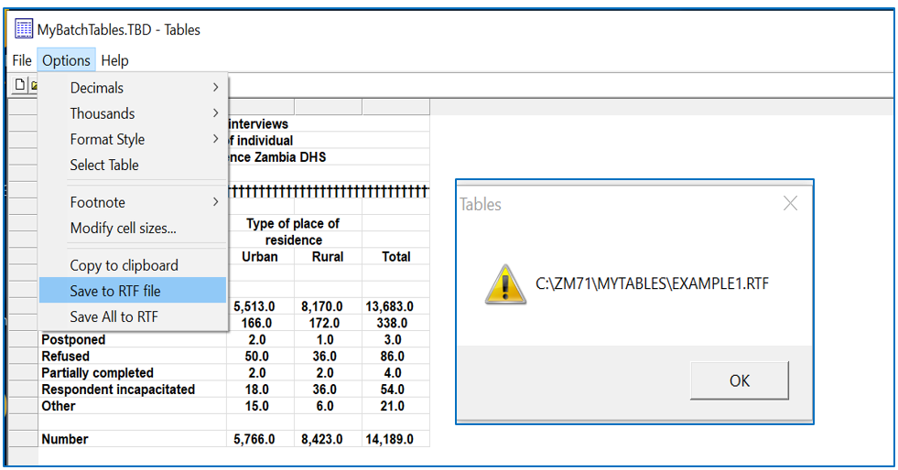

## 2.9 Save All Tables to a RTF File

Once a file has been opened and if no changes to tables are required, the user can save all tables produced by the application to an RTF file. To do this click on the Options main menu and then select the “Save All to RTF” option in the submenu.

If a parameters file was present at the time of opening the TBD file, the changes defined in the .PRM file will be applied before saving the tables. If no parameters file was present, TablesEditor will take the parameters passed by CSPro.

In general, the first time that a TBD file is opened, it is normally necessary to go through all the tables before saving them into an RTF file.

|  |
| --- |
|  |

## 2.10 Save Modifications

If you made modifications to any table, before exiting the program, TablesEditor will ask if you want to save the modifications. Saving modifications can be done at any time using the Save or Save as sub-menus of the File main menu.

Saving modifications are particularly important if the tables must be rerun and the same changes need to be applied for the new tables. This can be done because what is actually saved is the Parameters File. The next time that the tables are loaded TablesEditor will use those parameters.